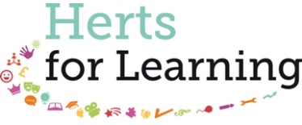
Herts for Learning Limited - Gender Pay Gap Report 2017

What is the ‘Gender Pay Gap’?
The gender pay gap measures the difference between men and women’s average salaries. New reporting regulations, under the Equality Act 2010, were introduced by the UK Government in 2017 requiring all employers with 250+ employees to publish outcomes to statutory calculations every year, showing the size (as a percentage difference) of any pay gap between their male and female employees.
Herts for Learning Hourly Pay Gap
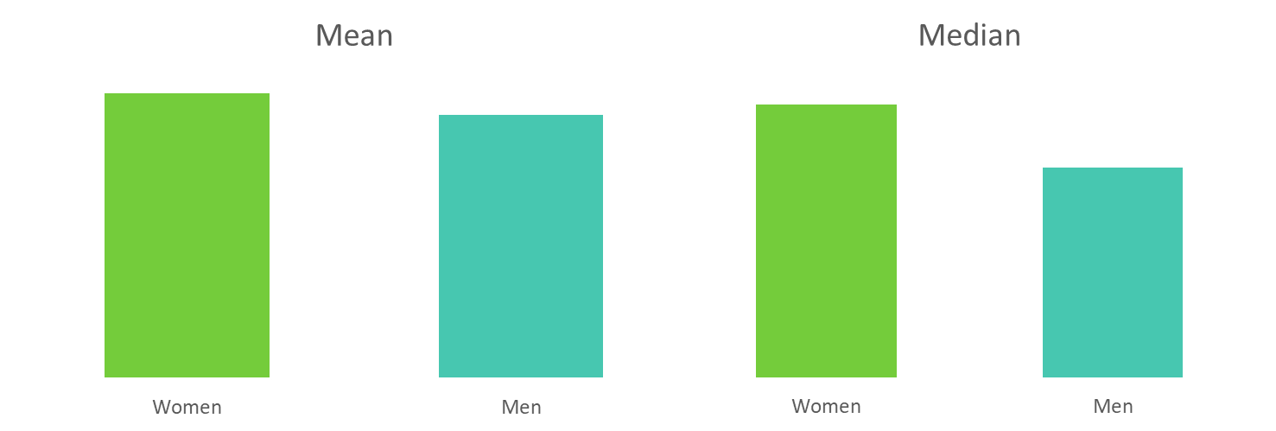
-29.60% Pay Gap
-8.25% Pay Gap
For clarity, the above results show hourly rate pay gaps in favour own our female members of staff. Nationally, the last reported median gender pay gap showed an an 18.1% male / female pay gap.
Herts for Learning Bonus Pay Gap
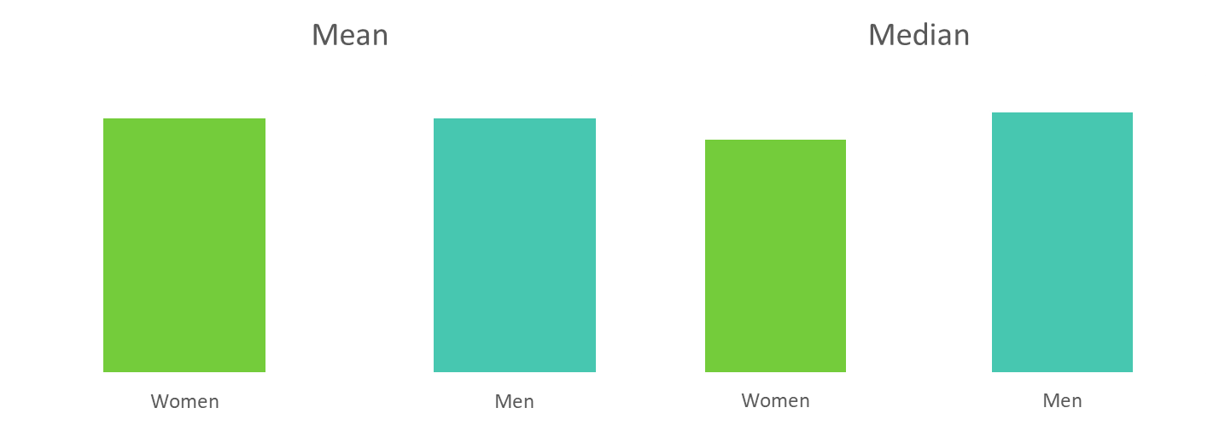
10.35% Pay Gap
-0.04% Pay Gap
For clarity, the above results show near identical mean bonus pay, and a median bonus pay gap in favour of our male members of staff. This is largely brought about by a high proportion of female variable hours staff. While these contractual hourly / daily rates of pay are more than competitive, variable work volumes mean the median female bonus pay is impacted.
In 2016/17, 53.5% of male staff and 66.7% of female staff employed by Herts for Learning received a bonus.
Pay Quartiles
In April 2017, 73.6% of Herts for Learning staff were female and 26.4% were male. The final requirement placed upon the Company is to segment our hourly rates of pay into quartiles, broken down by gender. The charts below sets out the percentage of female and male employees over four equal pay bands or quartiles.
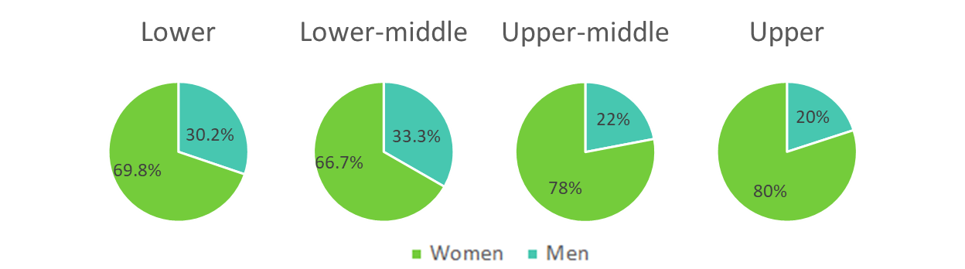
At Herts for Learning Limited we are committed to equality of opportunity and diversity within the workplace, which is fundamental in creating a trusted, inspirational and collaborative working environment, and Company. We will always endeavour to employ the best person for the job irrespective of protected characteristics such as gender and disability.
I confirm the data reported above is accurate.
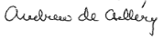

Andrew de Csilléry
Managing Director - Herts for Learning Limited

