Year 2
Topic: Plants
The class investigated seeds germinating by making observations over time and studied the text of ‘The Tiny Seed’ by Eric Carle. In English, they were set the tasks of planning and then writing a diary from the perspective of the seed to show its journey and the lifecycle of a plant.
Planning
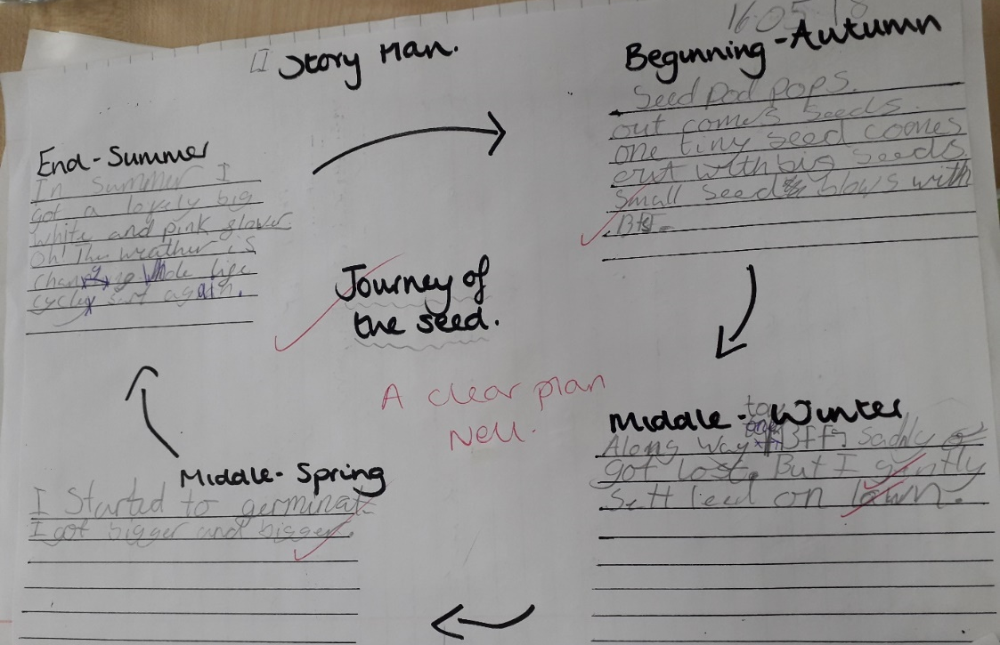

Final piece of writing:
One September day I was happily sleeping in my seed pod. Then all of a sudden my pod opened and the wind picked me and my friends. Two of my friends got lost and one got stuck in a tree. Eventually I settled down on a freshly cut lawn. In the night I wriggled until I was nice and warm in the soil.
It’s Winter now and its freezing cold. I really should get to sleep. Before I go to sleep my best friend got eaten by a very greedy rat. Luckily he missed me. I tucked up and eventually got to sleep. My last friend got dug up by a shovel but I stayed fast asleep.
Its getting warmer and I think it’s spring. All my friends are germinating but not me. One of my friends started growing really close to a really big weed it blocked out all the sunlight and rain so he died. Eventually I germinated and my roots started to grow down and my shoots went up. My roots became anchored in the soil and my shoots are stretching up to the sun.
It’s summer now and there are lots of other plants around. Look I’ve already got my big white and pink flower. Lots of birds, butterflies and bees gather round to see my huge flower.
Its getting cooler and the wind is getting stronger. It’s September and my seed pod pops and all my seeds have blown out. The wind carried them away to find their own homes and to start the life cycle.

