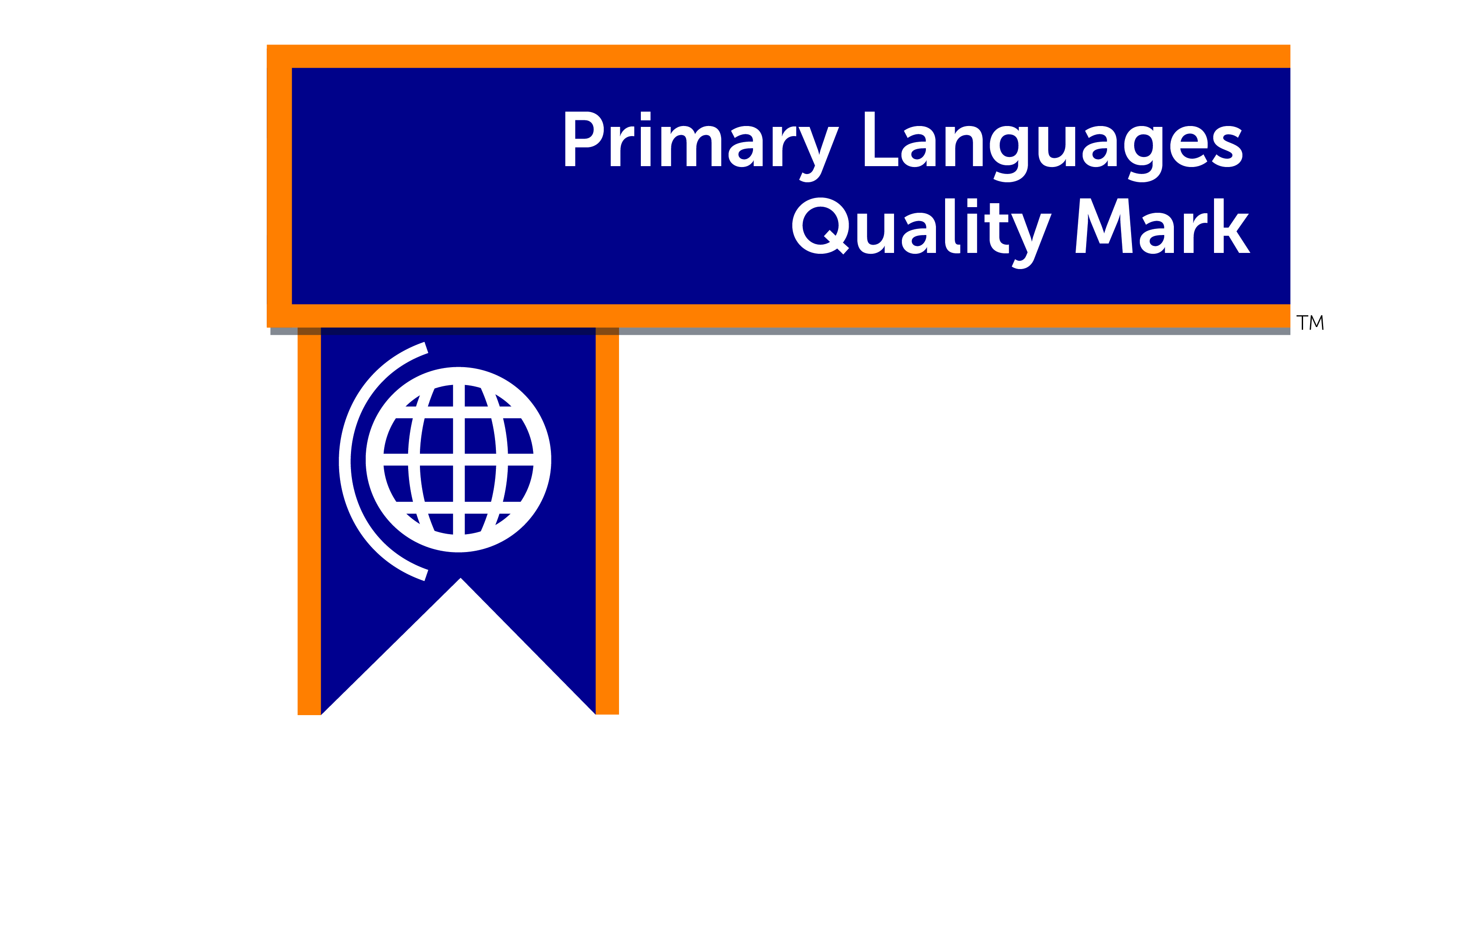
Supporting Quality Language Provision in Primary Schools

Primary schools are expected to provide foreign language teaching to every year group in key stage 2 from September 2014 and to ensure that teaching focuses on substantial progress in one language. The new programme of study for KS2 set outs the national requirements for the curriculum in primary languages (PL).
The Herts for Learning Primary Languages Quality MarkTM (PLQM) can help to audit, embed and evaluate the foreign language provision in your school through a series of incremental stages that guide you towards best PL practice and help you meet the new national requirements as set out in the programme of study for KS2. Schools can apply for a quality mark at either Bronze, Silver or Gold level by submitting an evidence-based portfolio.
Overview
 | Bronze | Silver | Gold
Curriculum planning and design | There is curriculum planning in place for the whole of key stage 2 which shows clear continuity and progression year on year. | The curriculum planning and design is partly tailored to the school context and supports learning in other curriculum areas or whole-school priorities such as literacy and numeracy. | There is a creative and engaging curriculum for PL, referencing essential language skills and topics and it is entirely adapted to the context and curriculum of the school.
Achievement, assessment and reporting | There is an agreed framework which is used to assess a broad range of pupil performance across the language skill areas. Data is shared and used to improve performance. | There is an agreed framework which is used to assess an even wider range of pupil performance (including peer and self-assessment) across the language skill areas. Data informs pupil learning. | The assessment framework used allows pupils the ownership of their language learning and ensures that robust and reliable data follows them through to key stage 3.
School and subject leadership and management | The school has an appointed PL Co-ordinator with a published job description. The school has a policy for PL teaching and entitlement and the relevant documentation to evidence thorough curriculum planning and review is in place. | There is a budget for staff training in PL and training needs are being identified and met. The school has a ‘languages governor’ charged with promoting the values of learning a foreign language and intercultural understanding. | School leader, subject leader and managers ensure that the school is pro-active in updating knowledge of current language teaching practice and developments and have an excellent understanding and overview of PL teaching.
Wider opportunities including the international dimension | The school is pro-active in making links to languages in a range of in-school events such as special assemblies or celebrations. The school holds the British Council International School Award Foundation Certificate* | The school arranges for special visitors or guest speakers to come to school. The school holds the British Council International School Award Intermediate Certificate or Full Award level. | Language learning opportunities outside school are part of the curriculum offer. The school holds the British Council International School Full Award.
Transition, continuity and progression. | Assessment data for student achievement in languages is shared with the pupils’ destination school(s). Teaching across key stage 2 provides a good foundation for study for key stage 3. | The school has formed links with outside agencies including local secondary schools. The school shares additional information (as appropriate) such as schemes of learning. | The school has regular contact and collaboration with local secondary schools (e.g., Strategic Learning Network membership, bridging projects, Y6 visits to secondary schools etc.).

You will need to provide evidence that you can meet the requirements of all criteria for each level of award. The award levels are cumulative (therefore to apply for the Silver award, the criteria for the Bronze award must also be met).
For further information and support, please contact: Jackie Rayment, MFL Adviser [jackie.rayment@hertsforlearning.co.uk]
HERTS FOR LEARNING
Robertson House
Six Hills Way
Stevenage
SG1 2FQ
September 2014

*https://schoolsonline.britishcouncil.org/accreditation-and-awards/international-school-award

